Secure, Contain, Protect
  - A SCP Containment Breach remake in Unity, with multiplayer.
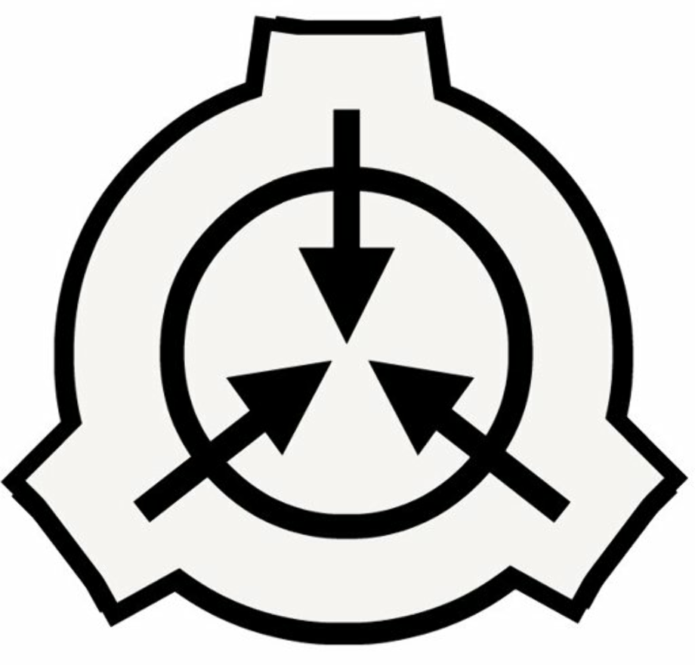
Contents
Basic idea 3
Basic systems 3
Level design 3
Items 4
SCP items 4
NPC’s 4
SCP NPC’s 4

Basic idea
A remake of the game SCP Containment Breach, a horror game in which the player must navigate a SCP facility in the middle of a catastrophic containment breach to escape with their life, facing multiple horrors and other obstacles along the way.

Basic systems
- Health: every player needs Health to live, if a player’s Health drops to zero, they will die. Health does not regenerate on its own, methods of healing will be needed to regain Health e.g., a first-aid kit. If every player dies, they lose. Players do not respawn, and can only spectate afterwards. Health is shown visually by a health bar in the lower left of the screen.
- Stamina: every player needs Stamina to sprint, if a player’s Stamina drops to zero, they will be unable to sprint from oncoming horrors. Stamina will regenerate on its own, but regeneration can be boosted using certain methods e.g., an adrenaline syringe or a fine gas mask. Certain elements will also impede Stamina regeneration or even prevent sprinting altogether.
- Blink: every player blinks every eight seconds, to allow for SCP-173 to move around whilst in sight. Blinking is a set timer which can be reset at the press of a button, at the cost of blinking. Certain elements will quicken or slow the blink meter e.g., eyedrops or steam blasting in the player’s eyes.
- Inventory: every player has its own inventory, storing up to ten items acquired along the way. Items acquired include keycards, gas masks, SCP objects, etc.
- Sprinting: every player can sprint, consuming Stamina to move faster. Certain elements may allow the player to sprint faster or slower e.g., an adrenaline syringe or being bitten by SCP-939.
- Sneaking: every player can sneak, sacrificing speed to move silently, potentially evading an unaware SCP.

Level design
The game takes place in a SCP facility, ergo the level design must be as followed:
- Facility-based: the level is entirely indoors, following a facility-like structure; tunnels, corridors, small storage rooms, offices, containment rooms, etc.
- Layer-based: the SCP facility exists out of three layers – light containment, heavy containment and the entrance zone.
  - Light containment: the lightest forms of SCP’s (Safe, Euclid) reside here, including class D personnel. This zone resembles a laboratory, looking very sterile and professional.
  - Heavy containment: the heaviest forms of SCP’s (Keter) reside here. This zone resembles a factory, looking heavy, tough and industrial.
  - Entrance zone: the administrative personnel reside here. This zone resembles a regular office, containing multiple small offices and a cafeteria.

Items
- Gas mask: allows the player to ignore the effects of gas at the cost of their field of vision.
  - “Super” gas mask: the gas mask upgraded in SCP-914, allows the player to sprint faster and longer whilst including the effects of the original gas mask.
  - “Heavy” gas mask: the gas mask combined in SCP-914 with SCP-148, grants the player immunity to the effects of SCP-012, SCP-895 and SCP-966 whilst including the effects of the original gas mask.
- Keycard: allows the player to open locked doors, containment cells and other rooms. Cards will be split per clearance level, up to Level 5. A keycard can be upgraded in SCP-914 to acquire the next clearance level, with the chance of it turning into a useless card instead. Upgrading a Level 5 keycard will turn it into the Omni-keycard, allowing it to open everything.
  - MasterCard/Playing card: a keycard “upgraded” in SCP-914, now turned useless. Can be turned into four quarters using SCP-914.
- First-aid kit: allows the player to regenerate Health, stopping bleeding and other (non-permanent) damaging or movement impairing effects.
  - Small first-aid kit: the first-aid kit upgraded in SCP-914, allowing the player to use it faster and more efficiently.
  - Blue first-aid kit: the first-aid kit “upgraded” in SCP-914, having a random effect instead of healing the player.
    - Increased speed, followed shortly by death.
    - Invert mouse controls.
    - Blurred vision.
    - Fully heal the player, potentially overhealing the player up to 150 Health.
    - Critically wound the player, bringing them down to 1 Health.
  - Strange bottle: the first-aid kit “upgraded” in SCP-914, having a random effect instead of healing the player.
    - Teleported to SCP-106’s Pocket Dimension.
    - Blurred vision.
    - Fully heal the player, potentially overhealing the player up to 150 Health.
    - Critically wound the player, bringing them down to 1 Health.
- Syringe: allows the player to sprint unimpaired, with no Stamina reduction for a limited time after injection. Also heals for a very small amount.
  - Fine syringe: the syringe upgraded in SCP-914, granting the same effects as the normal syringe but at a random time limit, longer or shorter. Also heals for a greater amount than the normal syringe.
  - Very fine syringe: the syringe “upgraded” in SCP-914, having a random effect instead of healing the player.
    - Sprint unimpaired for 30 seconds with no Stamina reduction, healing for a random amount.
    - Increased speed, follow shortly by death.
    - Vomit.
- Ballistic vest: provides the player protection against bullets at the cost of speed while worn. Only protects the chest and arms, not the legs and head.
  - Heavy ballistic vest: the ballistic vest upgraded in SCP-914, granting more protection against bullets at the cost of even more speed. Protects everything but the head.
  - Bulky ballistic vest: the ballistic vest “upgraded” in SCP-914, being so heavy that it is unable to be used anymore.
- S-Nav 300: a portable map database, proving the player with a minimap while held. Only already explored areas will be revealed. Consumes 9V batteries.
  - S-Nav 310: the S-Nav 300 upgraded in SCP-914, revealing the entire facility regardless of exploration. Consumes 9V batteries.
  - S-Nav Ultimate: the S-Nav 300/310 upgraded in SCP-914, revealing the entire facility regardless of exploration and detecting nearby SCPs in the vicinity, showing a red danger circle. No longer requires batteries.
- Hazmat suit: provides the player with protection against SCP-008 and SCP-049 while worn at the cost of reducing speed greatly.
  - “Heavy” hazmat suit: the hazmat suit combined in SCP-914 with SCP-148, also granting protection against SCP-012, SCP-895, SCP-966 and SCP-035’s tentacle creatures.
  - “Mysterious” hazmat suit: the hazmat suit upgraded in SCP-914, granting the same effects as the “super” gas mask in addition to the immunities.
- Radio: allows the player to listen to radio broadcasts within the facility, providing intel or just fluff and flavor. Consumes 9V batteries.
- 9V battery: a generic battery used to power multiple electronic devices.
  - 18V battery: the 9V battery “upgraded” in SCP-914, now only able to be fit in the radio.
  - “Strange” battery: the 9V battery “upgraded” in SCP-914, unable to be used as touching it will only electrocute the player.
- ReVision eyedrops: allows the player to extend their blink meter by an extra eight seconds.
  - Red eyedrops: allows the player to extend their blink meter by an extra sixteen seconds.
  - Dark red eyedrops: allows the player to extend their blink meter by an extra twenty-one seconds, at the cost of becoming completely blind after the set time due to not blinking.
- Severed hand: allows the player to open DNA-locked doors. A hand can be found in SCP-012’s chamber, opening the door to the large testing chamber, allowing the player to access deeper into the facility.
- Dark severed hand: allows the player to open DNA-locked doors. A hand can be found in Storage Area 6 (the area with multiple SCP-939’s), opening the small blast door in SCP-049’s containment chamber, bypassing its tunnels.
- Clipboard: allows the player to store up to ten documents, keycards, notes whilst using only a single inventory slot.
  - Fine clipboard: the clipboard upgraded in SCP-914, now storing up to fifteen files.
  - Very fine clipboard: the clipboard upgraded in SCP-914, now storing up to twenty files.
  - “Upgrading” a document in SCP-914 will result in origami, turning it useless, but pretty.
- Wallet: allows the player to store up to ten keycards, coins, keys and SCP-860 whilst using only a single inventory slot.
- Night vision goggles: allows the player to see in the dark, through the dark fog ahead. Obstructs vision with a green tint and scanlines. Makes the player vulnerable to SCP-895. Consumes 9V batteries.
  - “Super” (red) night vision goggles: the night vision goggles upgraded in SCP-914, no longer consuming batteries and granting resistance (not immunity) against SCP-895 and SCP-012. Obstructs vision with a red tint and scanlines.
  - “Super” (blue) night vision goggles: the night vision goggles upgraded in SCP-914, granting resistance (not immunity) against SCP-895. Detects and shows distance to nearby SCP’s and other hostiles through walls. Obstructs vision with a green tint and scanlines. Consumes 9V batteries.
- Quarters: allows the player to purchase a cup of SCP-294.

SCP items
- SCP-148: a metallic plate consisting of multiple unknown metals. When upgraded in SCP-914, turns into an ingot used as an upgrade component for the “heavy” gas mask or hazmat suit.
- SCP-427: a small silver locket, healing the player slowly when opened but turning them into an instance of SCP-427-1 when exposed to it for too long.
- SCP-500: a bottle of pills containing multiple SCP-500-1 pills, healing the player instantly and fully curing every ailment.
  - Pill: a pill of SCP-500-01 “upgraded” in SCP-914, now made inert and thus useless.
  - “Upgraded” pill: a regular pill “upgraded” in SCP-914, now made inert but also dangerous, turning the player into an SCP-427-1 instance.
- SCP-513: a rusty cowbell, summoning SCP-513-1 to haunt the player when rung. The only way to get rid of SCP-513-1 is to destroy SCP-513.
- SCP-714: a green jade ring, protecting the player against SCP-049, SCP-895, diseases from SCP-1025, SCP-1123 and SCP-012 while worn at the cost of greatly reduced speed and Stamina.
- SCP-860: a dark blue key, opening any door lock that requires a key, transporting the player to SCP-860-1.
- SCP-1025: a hardcover book titled “The Encyclopedia of Common Diseases”. Any disease read by the player will be acquired.
  - Appendicitis: reduces Stamina recovery and speed after a while.
  - Asthma: random coughing, lowering speed proportional to remaining Stamina.
  - Cardiac Arrest: instant death.
  - Chickenpox: random “Your skin is feeling itchy.” messages.
  - Common Cold: random coughing, lowering Stamina recovery.
  - Lung Cancer: random coughing, greatly lowering Stamina recovery.
- SCP-1499: a Soviet GP-5 gas mask, transporting the player to an alternate dimension whilst worn, infested with SCP-1499-1 instances.
- SCP-420-J: joke item. Using it makes Rasta-music play, blurring the player’s vision slightly whilst making text appear saying “Man, that’s some good ass shit!”.
  - Joint/Smelly joint: SCP-420-J “upgraded” in SCP-914, now being an instant death instead of a funny easter egg. “Uh where… what was I doing again? Man… I need to take a nap…”
  - Cigarette: SCP-420-J “upgraded” in SCP-914, now being useless, just prompting text to appear. “Even if I wanted one, I have nothing to light it with.”

NPC’s

SCP NPC’s

Miscellaneous SCP’s
- SCP-008
- SCP-294
- SCP-860-1
- SCP-1162
- SCP-789-J

